EXP NO 4: CREATE A SIMPLE CLOUD SOFTWARE APPLICATION FOR CAR BOOKING RESERVATION SYSTEM USING ANY CLOUD SERVICE PROVIDER TO DEMONSTRATE SAAS.
AIM: To Create a simple cloud software application for Car Booking Reservation System using any Cloud Service Provider to demonstrate SaaS.
PROCEDURE:
Step1: Go To Zoho.Com.
Step 2: Log Into The Zoho.Com.
Step 3: Select One Application Step.
Step4: Enter Application Name As Car Booking Reservation System.
Step 5: Created New Application As Car Booking Reservation System.
Step 6: Select One Form
Step 7: The Software Has Been Created.
IMPLEMENTATION:
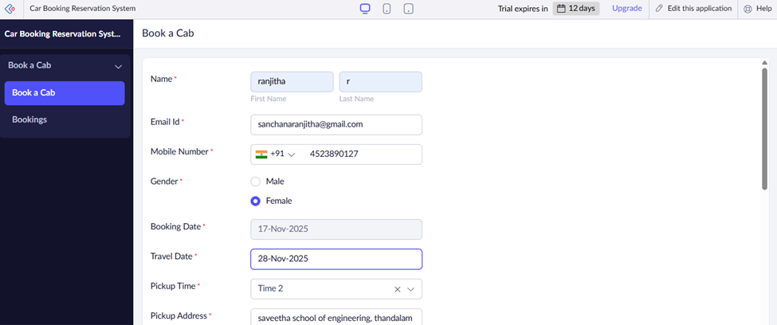
OUTPUT
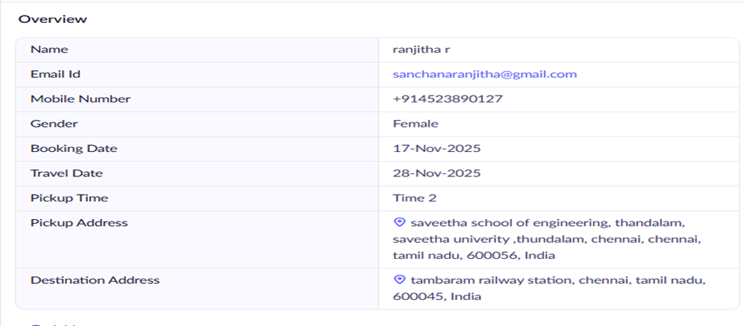
RESULT:
Thus a simple cloud software application for Car Booking Reservation System using any Cloud Service Provider to demonstrate SaaS was done successfully.

